Packing List

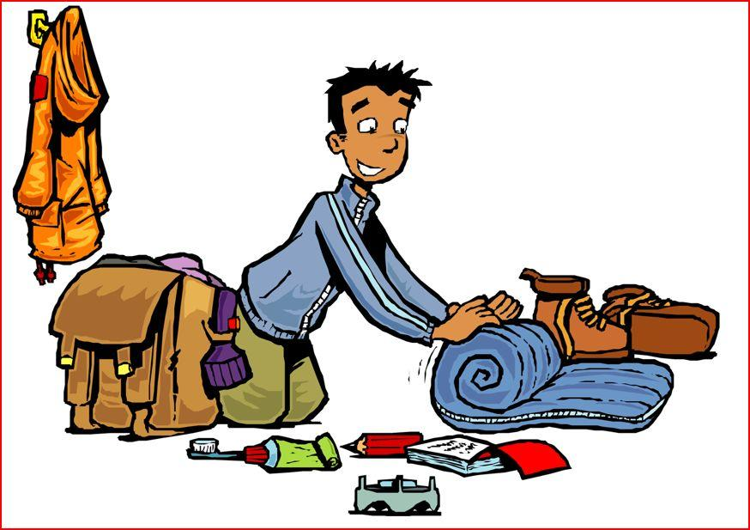

Bring to Camp:

- Sleeping bag and pillow
- Two towels
- Waterbottle
- Sunscreen (including face protection)
- Raincoat
- Clothes for 1 week (undies and socks, too!) Shorts may not be shorter than fingertips.
- Soap and personal toiletries (don’t forget your toothbrush!)
- Warm jacket (it gets cool at night)
- Plastic bag for wet clothes
- Flashlight and batteries
- Swimsuit (Girls: Please wear one-pieces or tankinis)
- Tennis shoes
- Insect repellent
- Sunglasses
- Flip-flops/water shoes/sandals for showers and at the Waterfront
- Optional: Snacks for Free Time that will be kept in the Canteen

Leave at Home:
Parents, we ask for your help with these items as they can quickly distract from the camp community. Items found in the possession of a camper will be confiscated and returned at the end of the week.

- Cell phones
- MP3/CD players/radios
- Video games, tablets
- Any other electronics
- Cash
- Drugs/alcohol/tobacco
- Guns/knives/weapons

All the Music Supplies:
- Musical instrument
- Folding music stand
- Clothespins or other clips to hold music to your stand for outdoor events!
- Any musical accessories you may need (reeds, rock-stops, rosin, valve oil, etc.)
- Any pieces of music you may want to work on or perform- you never know when an opportunity might arise!

